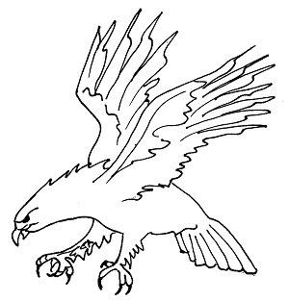
Welcome to 6th Grade Health at Skyview Upper Elementary School with Ms. Numerato. Below you will find the answers to the most frequently asked questions to guide you through a successful school year.
Skyview Upper Elementary School
5th Grade Health

- How often will I have Health class?
  - 1 day per cycle (A, B, C, D, E, F) for 43 minutes each day
- What materials will I need to bring to health class?
  - You will need to BRING a pencil every health class.
  - A folder will be PROVIDED for you and you will LEAVE your folder IN THE HEALTH ROOM.

- What is your homework policy?
  - It is expected that assignments will be completed and turned in to Ms. Numerato during health class on the day that they are due.
  - Homework: You will not hand homework in, but it will be checked for completeness.
    - Complete = 4 points
    - Partially complete = 2 points
    - Nothing done= 0 points
  - Collected Assignments: Assignments that will be handed in and graded. All assignments not handed in on time will be deducted 10% for every health class the assignment is late.
- What if I am absent from school or leave early for a music lesson?
  - You will be responsible to make up the work.
  - See me, check the never too late bin or email me to find out what you missed as soon as you return to school.
  - If we have a test, quiz, or special project the day you have lessons, please make arrangements to reschedule your lesson in advance so you do not miss class.
- How can I get in contact with Ms. Numerato?
  - Email: Enumerato@methacton.org
  - Teacher Website: http://elmanumerato.weebly.com/
    - Information will be posted frequently on my teacher website.
- What units will we cover?
- Nutrition
- Fitness
- Personal Pollutants
- Safety
We are going to have a fun, exciting year!
Looking forward to a GREAT year!
~ Ms. Numerato

